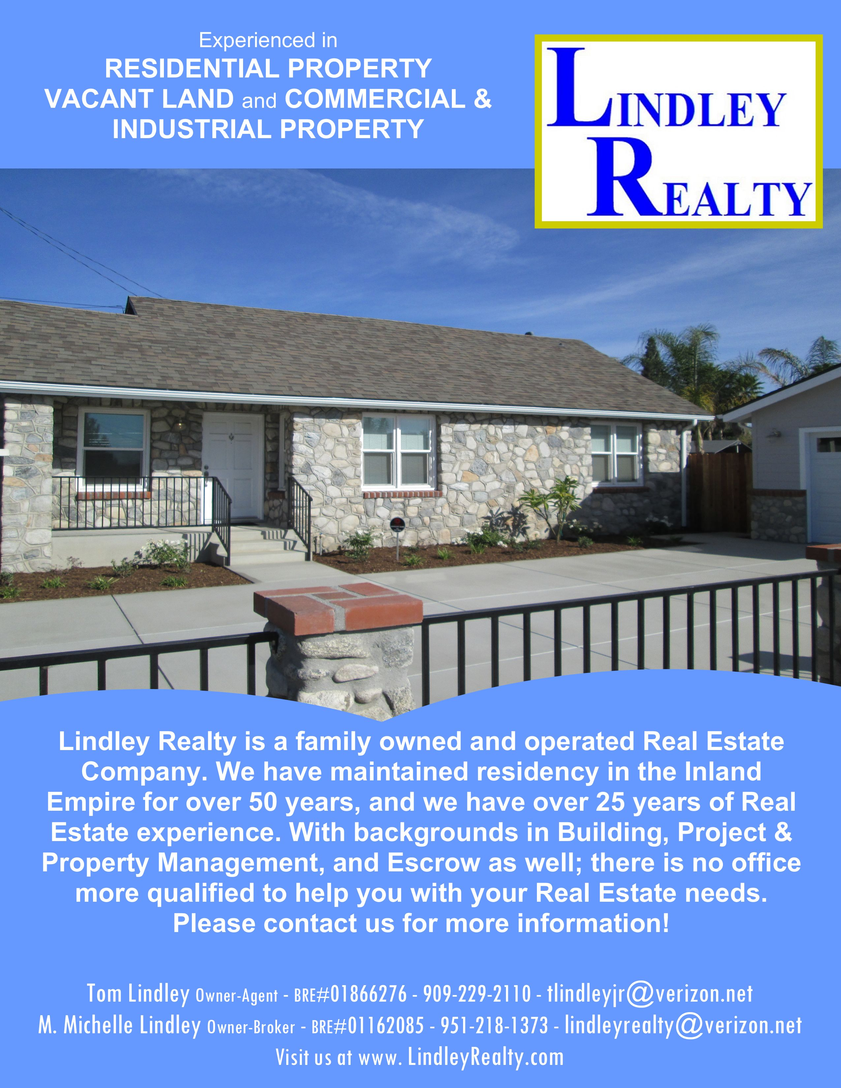

Don’t let our size fool you!

Buying or selling property today requires local knowledge & guidance, and
a Real Estate professional that can provide you with both. We have the
expertise to help you navigate today's Real Estate market, and provide you
a traditional, full service approach.
As an experienced Residential Broker, buying and selling homes &
investment properties, we can help you negotiate the extensive and
intricate contract, negotiation, and escrow process. As an experienced
Land Broker, we know the unique nuances of buying and selling land and commercial properties as well.
We are a family owned and operated company, so you can always count
on talking to "your" REALTOR®, not someone's assistant or secretary.
You have complete access to two REALTORS® who know your account,
discuss your progress, and monitor your transaction - TWO for the price of one!
With over 25 years of Real Estate, Escrow, and Building experience, there is
no one more qualified to help you buy or sell & make your dreams a reality.
Let us put our experience to work for you.

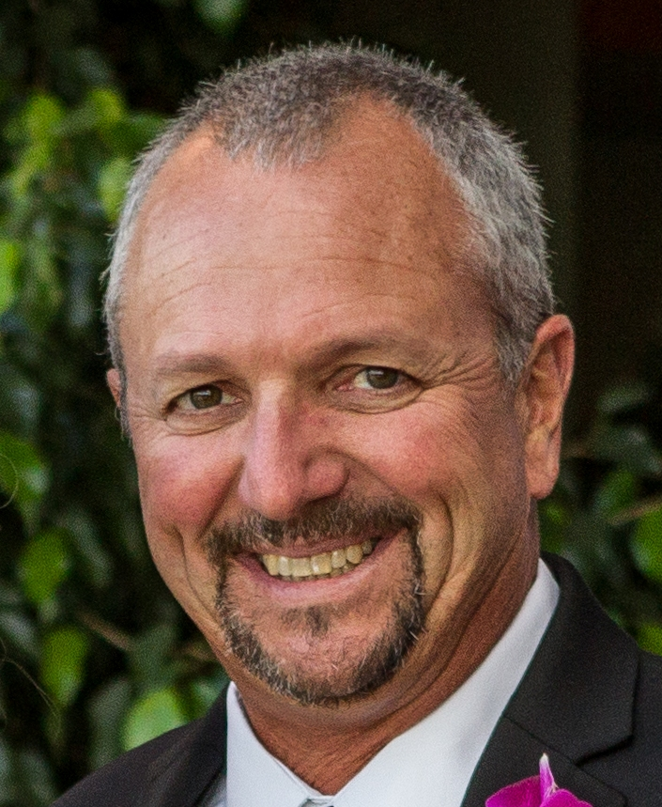
Michelle Lindley
Owner/Broker
Tom Lindley
Owner/Agent

Because we are REALTORS®, we are members of The National Association of Realtors (NAR),
The California Association of Realtors (CAR),
and The Inland Valley Association of Realtors (IVAR), and we have the ability to use all the Realtor Associations’ resources for you.
We have access to:
* Consumer and Realtor insights, trends, and news.
* Regular updates to changes in Real Estate Law and Lender Requirements
* Marketing trends, data, and statistics
* The Multiple Listing Service (MLS) and Realtor Advertising opportunities,
And much more


Your property’s listing is placed into the Multiple Listing Service (MLS). This service reaches not only REALTORS® in your area, but also REALTORS® across the country. The service allows other REALTORS® who may represent potential buyers to see your property’s listing. Likewise, the service also allows us to find other properties in a desired area for you.

Your home is also listed on the major home search sites such as Zillow, Trulia, and Realtor.com directly from the MLS.

We advertise your property to REALTORS® in surrounding counties like San Bernardino, Los Angeles, Riverside, and Orange by way of E-Flyers. These flyers reach the inbox of all Association REALTORS® in each of the selected counties within moments.
We also advertise your property on site by way of Property
Flyers. These flyers are available at your listing to neighbors and other visitors who may know potential buyers for your area.

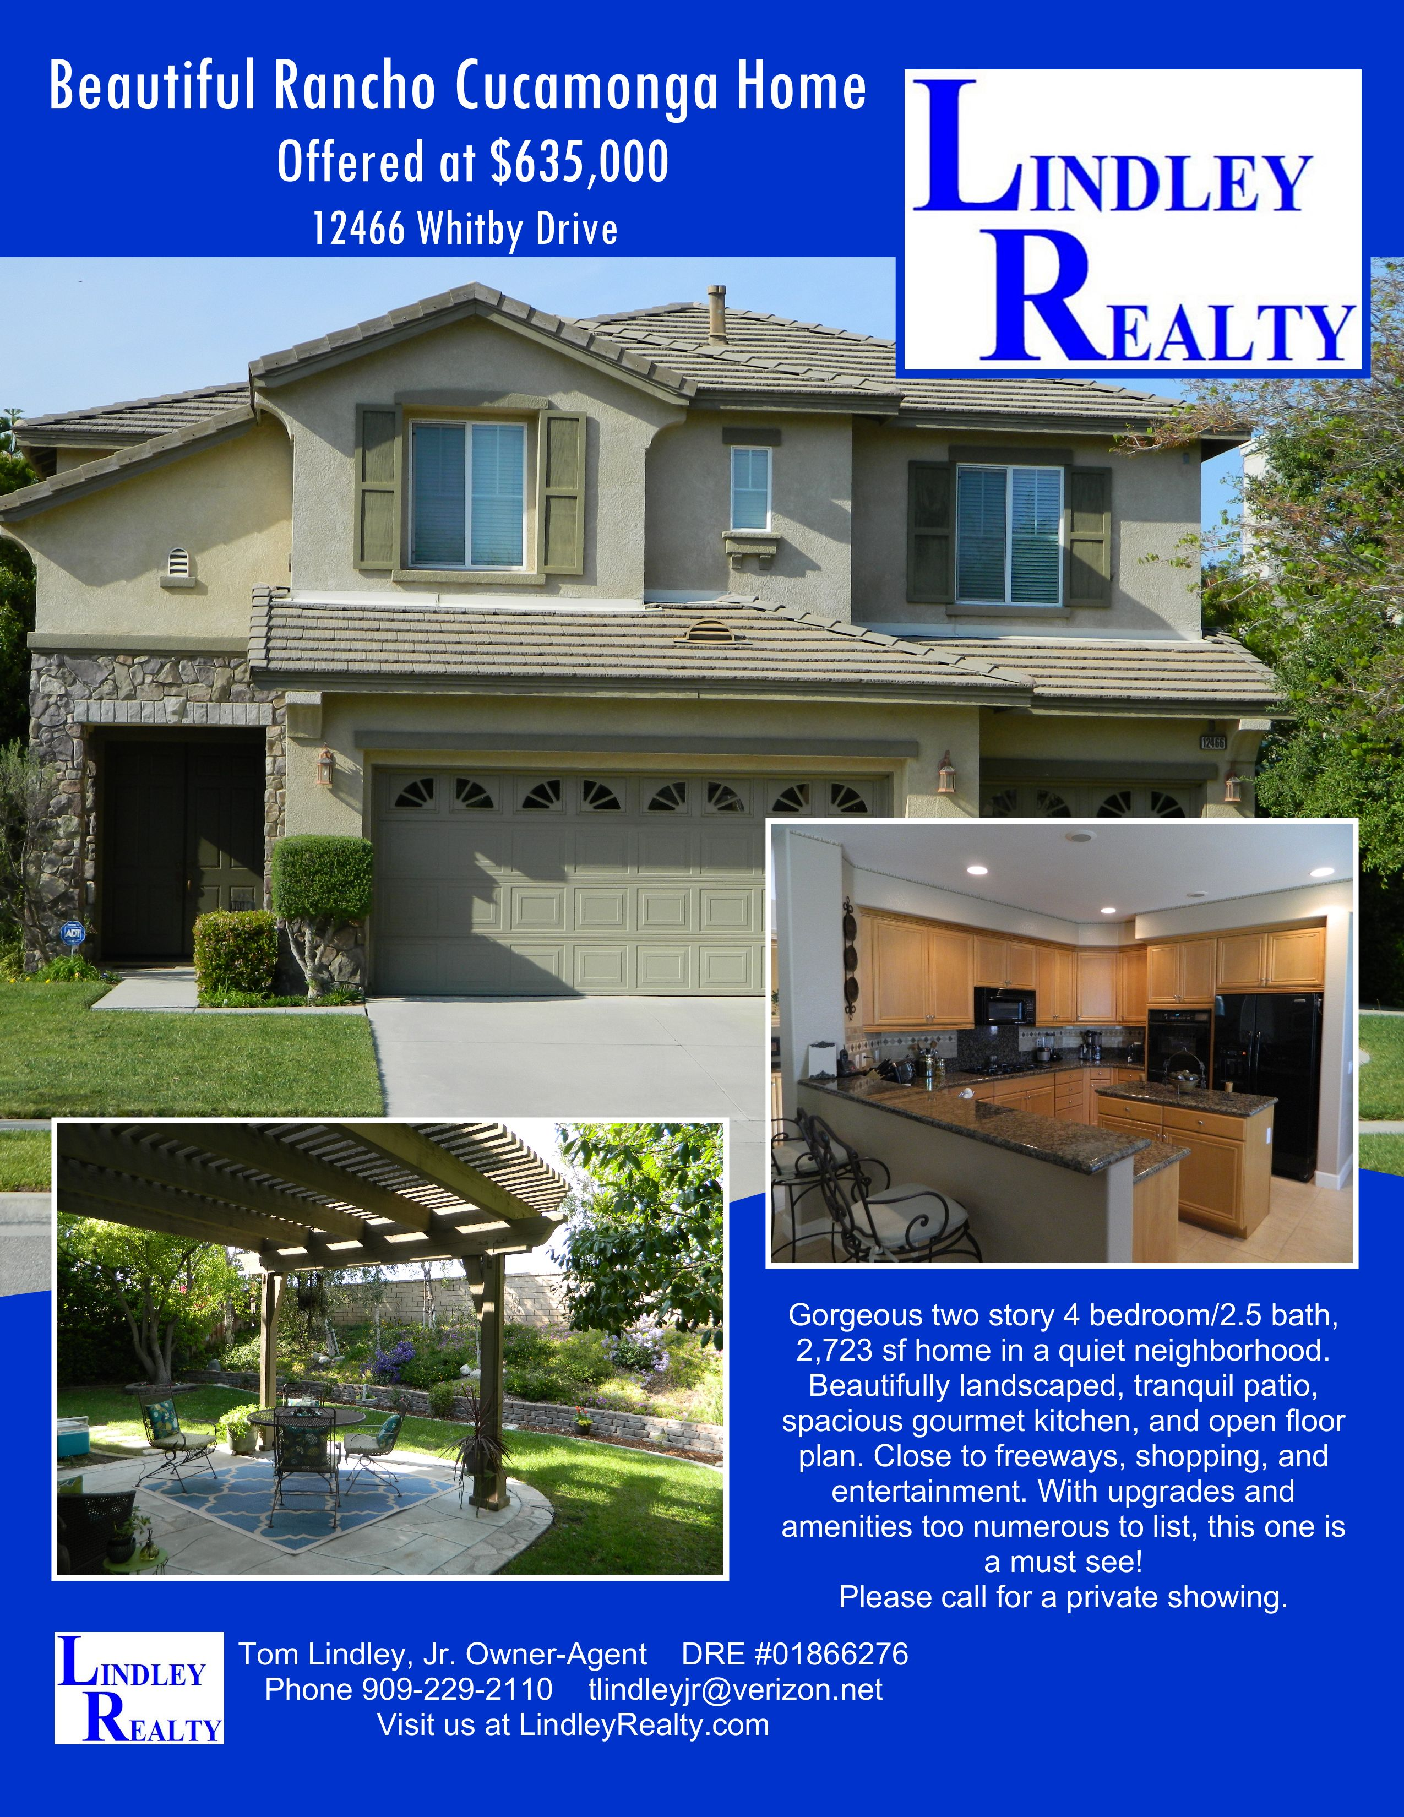

We promote our listings at LindleyRealty.com and Social Media.

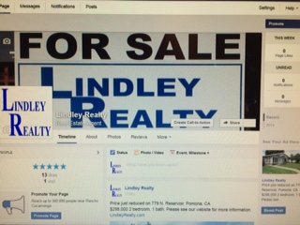
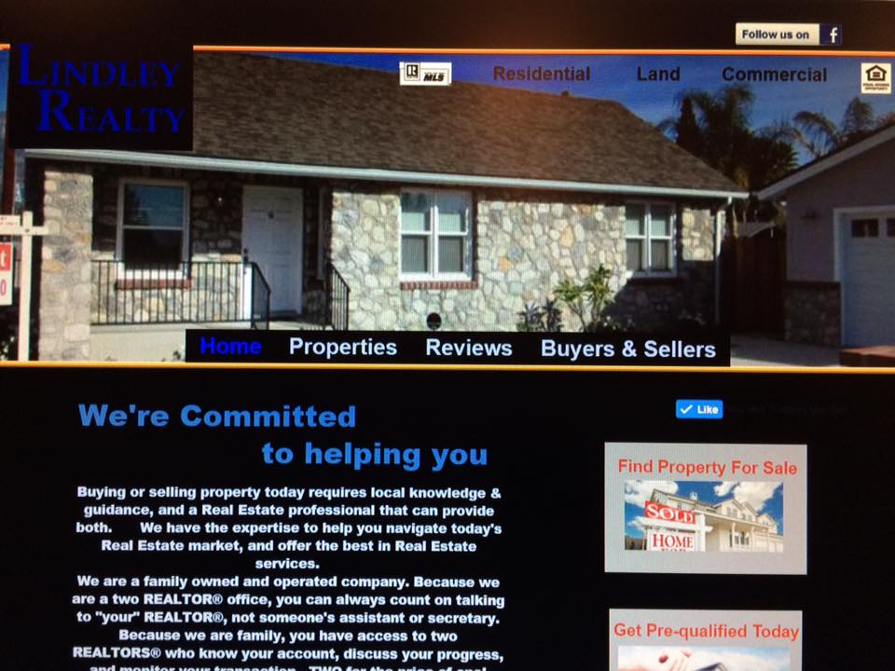

 RECENT CLOSED SALES

Vacant Land
Desert View Dr., Pinon Hills;
Residential Land 2.2 Acres
Sold at $25,000

10179 8th St., Rancho Cucamonga;
Residential Land 8,500 sq.ft.
Sold at $70,000

Grove Street, Rancho Cucamonga; Commercial Land 2.74 Acres
Sold at $1,200,000 in 42 days

Salina St., Upland;
Residential Land 10,500 sq. ft.
Sold at $118,000 in 30 days

S. Oaks, Ontario;
Residential Land, 2 Parcels
total 3.84 acres.
Sold at $830,000 in 34 days

W. Mission Blvd., Ontario;
Commercial Land 3.79 acres
Sold at $1,072,500 in 250 days

Arapaho, Rancho Cucamonga; Residential Land 3.36 acres
Sold at $775,000

14th Ave., Upland;
Residential Land 10,440 sq.ft.
Sold at $110,000 in 99 days

7940 Sierra Vista, Rancho Cucamonga; Residential Land 11,200 sq. ft.
Sold at $195,000 in 4 days

Vineyard Ave., Rancho Cucamonga; Residential Land 19,050 sq. ft.
Sold at $210,000

Single Family Homes
8325 Calle Del Prado, Rancho Cucamonga;
4 bedrooms, 3 baths, 2,248 sq. ft.
Sold at $649,000

7707 Calle Casino, Rancho Cucamonga;
3 bedrooms, 2 baths, 1,600 sq. ft.
Sold at $515,000

8388 Via Airosa, Rancho Cucamonga;
4 bedroom, 2.5 bath, 1,284 sq. ft.
Sold at $475,000

824 Sheridan St., Upland;
3 bedroom, 2 bath, 1,242 sq. ft.
Sold at $406,000

7492 Camino Norte, Rancho Cucamonga
3 bedroom, 2 bath, 1,690 sq. ft.
Sold at $526,320

7243 Rancho Rosa Way, Rancho Cucamonga;
4 bedroom, 2 bath, 1,862 sq. ft.
Sold at $498,000

7781 Valle Vista Dr., Rancho Cucamonga;
4 bedroom, 3 bath, 2,482 sq. ft.
Sold at $550,000

17605 Pinedale Ave., Fontana;
3 bedroom, 2 bath, 1,420 sq. ft.
Sold at $350,000

1255 Upland Hills Dr. S, Upland;
3 bedroom, 2 bath, 1,689 sq. ft.
Sold at $525,000

7636 Valle Vista Dr., Rancho Cucamonga;
3 bedroom, 2 bath, 1,878 sq. ft.
Sold at $520,000

259 Avenida Lobeiro, San Clemente;
3 bedroom, 2 bath, 1,415 sq. ft. Condo
Sold at $1,320,000

REVIEWS

"Definitely a Full Service Company!"
"When Tom first introduced himself to us he said he was a full-service realtor. We had no idea what that meant until working with Tom and Michelle on the sale of our house. From beginning to end Tom made the escrow process so much easier with all his extra help, patience, and willingness to be available at the drop of a hat. All paperwork was done in our home, at our convenience, and Tom's advice before, during, and after the sale was always spot on. Tom and Michelle are truly knowledgeable about the real estate business, and absolutely make the crazy process, and mounds of paperwork, so much easier to navigate with their personal care. They are a true pleasure to work with and definitely a full service company!"
MW & MW - Mission Viejo

"We highly recommend them!"
"Tom and Michelle have been our realtors for several years. They did a great job with my family estate sales which included commercial & residential. They are honest, personal, & a joy to work with!
5 Stars”
LN & BN - Upland/Ontario

"We Appreciate You!"
"Thank you Michelle & Tom for doing such a great job pulling all this together and for the good work you did to facilitate the selling of our home. We appreciate you!"
​BS & JS - Ontario

"Michelle was amazing!"
"She was able to help my family and I find and buy our first home. Michelle helped us through the whole process until we had the keys in our hands. If we had any questions after we moved in she would still help us with any thing we needed. If your looking for a professional, kind and caring realtor Michelle is your girl!"
SV & JV – Hesperia

"Can't say enough good things about Tom and Michelle!"
"They sold our house for over list price in just 3 days and worked a great deal to get us into our new home! If you're looking for great personal and professional service look nowhere else!"
KH & SH - Rancho Cucamonga

